Why Is This C.E.O. Bragging About Replacing Humans With A.I.?

Noam Scheiber

Ask typical corporate executives about their goals in adopting artificial intelligence, and they will most likely make [vague pronouncements](https://fortune.com/2023/05/11/reid-hoffman-ai-every-information-job-2-to-5-years/) about how the technology will help employees enjoy more satisfying careers, or create as many opportunities as it eliminates. A.I. will “help tackle the kind of tasks most people find repetitive, which frees up employees to take on higher-value work,” Arvind Krishna, the chief executive of IBM, [wrote](https://fortune.com/2023/04/20/ibm-ceo-work-ai-artificial-intelligence-careers-tech-arvind-krishna/) in 2023.

And then there’s Sebastian Siemiatkowski, the chief executive of Klarna, a Swedish tech firm that helps consumers defer payment on purchases and that [has filed paperwork to go public](https://www.wsj.com/business/swedens-klarna-files-for-u-s-ipo-c5b56c79) in the United States with an expected valuation north of $15 billion.

Image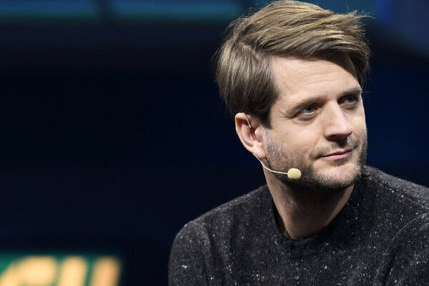

Sebastian Siemiatkowski, the chief executive and a co-founder of Klarna, has repeatedly talked about how much his company has saved from using artificial intelligence tools to automate work humans typically do.Credit...Lehtikuva/Reuters

Over the past year, Klarna and Mr. Siemiatkowski have repeatedly talked up the amount of work they have automated using generative A.I., which serves up text, images and videos that look like they were created by people. “I am of the opinion that A.I. can already do all of the jobs that we, as humans, do,” he [told](https://www.bloomberg.com/news/videos/2024-12-12/klarna-ceo-on-us-banking-ambitions-video) Bloomberg News, a view that goes far beyond what most experts claim.

According to Klarna, the company has saved the equivalent of [$10 million annually](https://www.wsj.com/articles/klarna-marketing-chief-says-ai-is-helping-it-become-brutally-efficient-4ad388d3) using A.I. for its marketing needs, partly by reducing its reliance on human artists to generate images for advertising. The company [said](https://www.klarna.com/international/press/90-of-klarna-staff-are-using-ai-daily-game-changer-for-productivity/) that using A.I. tools had cut back on the time that its in-house lawyers spend generating standard contracts — to about 10 minutes from an hour — and that its communications staff uses the technology to classify press coverage as positive or negative. Klarna has [said](https://www.klarna.com/international/press/klarna-ai-assistant-handles-two-thirds-of-customer-service-chats-in-its-first-month/) that the company’s chatbot does the work of 700 customer service agents and that the bot resolves cases an average of nine minutes faster than humans (under two minutes versus 11).

Mr. Siemiatkowski and his team went so far as to [rig up an A.I. version of him](https://www.linkedin.com/posts/davidsandstrom_for-the-first-time-klarnas-q3-update-is-activity-7266801208990867456-B4OY/?utm_source=share&utm_medium=member_desktop) to announce the company’s third-quarter results last year — to show that even the C.E.O.’s job isn’t safe from automation.

In interviews, Mr. Siemiatkowski has made clear he doesn’t believe the technology will simply free up workers to focus on more interesting tasks. “People say, ‘Oh, don’t worry, there’s going to be new jobs,’” [he said on a podcast](https://www.youtube.com/watch?v=m3niSE-8ZvE) last summer, before citing the thousands of professional translators whom A.I. is rapidly making superfluous. “I don’t think it’s easy to say to a 55-year-old translator, ‘Don’t worry, you’re going to become a YouTube influencer.’”

Mr. Krishna, the IBM chief executive, [once turned heads when](https://www.bloomberg.com/news/articles/2023-05-01/ibm-to-pause-hiring-for-back-office-jobs-that-ai-could-kill?embedded-checkout=true) he said A.I. could prompt the company to slow or pause hiring for the roughly 10 percent of its jobs involving back-office roles like human resources.

**Editors’ Picks**

](https://www.nytimes.com/2025/01/31/dining/graber-california-olives.html)](https://www.nytimes.com/2025/01/31/dining/graber-california-olives.html)

[These California Olives Are Unique and Delicious. They May Already Be Gone.](https://www.nytimes.com/2025/01/31/dining/graber-california-olives.html)

](https://www.nytimes.com/2025/02/01/obituaries/annie-easley-overlooked.html)](https://www.nytimes.com/2025/02/01/obituaries/annie-easley-overlooked.html)

[Overlooked No More: Annie Easley, Who Helped Take Spaceflight to New Heights](https://www.nytimes.com/2025/02/01/obituaries/annie-easley-overlooked.html)

](https://www.nytimes.com/2025/02/03/style/heavy-traffic-magazine.html)](https://www.nytimes.com/2025/02/03/style/heavy-traffic-magazine.html)

[A Magazine With a Taste for Provocation (and a Cult Following)](https://www.nytimes.com/2025/02/03/style/heavy-traffic-magazine.html)

For his part, Mr. Siemiatkowski [said](https://www.reuters.com/technology/artificial-intelligence/swedens-klarna-says-ai-chatbots-help-shrink-headcount-2024-08-27/) that A.I. had allowed his company to largely stop hiring *entirely*as of September 2023, which he said reduced its overall head count to under 4,000 from about 5,000. He said [he expected](https://www.bbc.com/news/articles/c80e1gp9m9zo) Klarna’s work force to eventually fall to about 2,000 as a result of its A.I. adoption. (Mr. Siemiatkowski and Klarna declined to comment for this article.)

Image

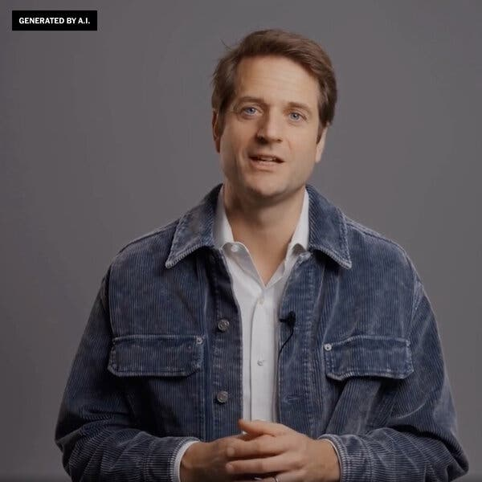

An A.I.-generated video of Mr. Siemiatkowski announcing the company’s earnings last year.

One might be tempted to conclude that Mr. Siemiatkowski is simply unfamiliar with the political sensitivity around questions of automation, or with the best practices for communicating about it to skeptical employees. (“Leaders can combat this initial resistance by highlighting how A.I. can help people focus on more meaningful work,” an [IBM study](https://www.ibm.com/downloads/documents/us-en/10a99803fd2fdd77) said.)

But Mr. Siemiatkowski is well aware of the backlash that his bluntness can provoke. “We did a tweet later on about the marketing things we are doing about A.I., where we have less need for photographers,” he said in the [podcast interview](https://www.youtube.com/watch?v=m3niSE-8ZvE). “That had a violent reaction online.”

Instead, interviews with former employees and transcripts of internal company meetings suggest that Mr. Siemiatkowski’s pronouncements about A.I. are motivated by something altogether different from political naïveté or an impulse for real talk. And those motivations shed light on the A.I. future that many executives and investors are working to bring about.

**Leaning In to Automation**

So far, most large companies do not appear to be replacing workers en masse. A [report](https://evidentinsights.com/reports/key-findings-report-2024-public?id=0c0fe37fa5) on 50 large banks by Evident, a firm that analyzes A.I. adoption, found that they typically derive other benefits from the technology, like improving services or helping employees work faster.

In [a paper](https://www.nber.org/papers/w31161) exploring one area that Klarna has highlighted, customer service, the Stanford economist Erik Brynjolfsson and two co-authors found that A.I. made many employees more productive when it came to relatively complicated tasks, like navigating customers’ tax issues.

The bot did this by excelling at certain simpler tasks, like advising the human on the optimal order in which to request information from a customer. But it didn’t handle the interaction from start to finish. (In fairness, the experiment didn’t attempt full automation.) “I think people exaggerate how much they can automate everything in the near term,” said Dr. Brynjolfsson, though he acknowledged that more tasks could be automated as A.I. became more powerful over the next few years.

When pressed, Mr. Siemiatkowski has conceded that the picture is somewhat more complicated than his company’s news releases have suggested. He explained on [another podcast](https://www.youtube.com/watch?v=34P1XLXmEUI) that Klarna had been relying on humans to perform customer service tasks that other companies had automated long before A.I., like instructing a customer where to go on the Klarna app to delay a payment. As a result, Klarna replaced more workers than other companies would have replaced.

His claims about hiring may have been overblown, too. The website TechCrunch [searched through](https://techcrunch.com/2024/12/14/klarnas-ceo-says-it-stopped-hiring-thanks-to-ai-but-still-advertises-many-open-positions/) Klarna’s job listings more than a year after the company supposedly stopped hiring and found more than 50 openings in a variety of jobs. A Klarna spokesman told the outlet that the company was “not actively recruiting to expand the work force but only backfilling some essential roles” like engineering, and that Mr. Siemiatkowski had been “simplifying for brevity in a broadcast interview.”

But all of this raises the question: At a moment when A.I. is already [alarming](https://www.nytimes.com/2023/03/28/business/economy/jobs-ai-artificial-intelligence-chatgpt.html) office workers, why would a chief executive not only speak candidly about his company’s progress in automating jobs, but even *overstate* the case?

**A Self-Mythologizing Rise**

The son of Polish nationals who immigrated to Sweden in the early 1980s, not long before he was born, Mr. Siemiatkowski grew up feeling like something of an outsider in his parents’ adopted country. He [has talked](https://www.youtube.com/watch?v=HkNBqn-nGlMc) of being teased as a child. According to former employees, he once said that feeling like an outsider helped him empathize with Black Americans after the killing of George Floyd.

Mr. Siemiatkowski founded Klarna, then known as Kreditor, in 2005 with two classmates after a telemarketing job [alerted him to the problems](https://www.acquired.fm/episodes/building-a-disruptive-payments-company-with-klarna-ceo-sebastian-siemiatkowski) that small companies had collecting payments from online customers. The idea was to guarantee the payment for merchants and collect from the customer later.

It was an old retail practice known as “buy now, pay later,” except updated for the internet age.

The company quickly turned a profit by charging merchants a fee for the payment service, and began expanding across Europe and taking business from banks. By 2010, Klarna had [renamed itself Klarna](https://www.klarna.com/international/klarna-history/), meaning “clear,” and had begun to attract the attention of Silicon Valley investors.

Image



Klarna’s offices in central Stockholm. Mr. Siemiatkowski founded Klarna in 2005 with two classmates after he learned about the difficulties that small companies had collecting payments from online customers.Credit...Loulou d'Aki for The New York Times

Mr. Siemiatkowski gave the impression of someone who had for years been playing out the moment in his mind. When the famed Silicon Valley venture capital firm Sequoia dispatched a partner to Sweden to pitch the co-founders on an investment, telling them Sequoia thought they could transform banking the way Google had changed the internet, Mr. Siemiatkowski was quick to pipe up. “Just tell me one more thing,” he said, recalling the exchange to [Forbes magazine](https://www.forbes.com/sites/parmyolson/2016/11/07/buy-now-pay-later/) years later. “If we’re going to be the Google of banks, would you really just send you? Wouldn’t the whole of Sequoia come here?”

The Sequoia partner quickly connected the founders with Michael Moritz, one of the firm’s high-profile investors. Mr. Moritz apologized for not appearing in person and later joined Klarna’s board.

Mr. Siemiatkowski, who with his strong jaw and blue eyes looks like a long-lost Hemsworth brother, seemed to style himself as the kind of tech mogul investors were eager to back. Former employees said the company’s hiring process for engineers resembled that of a Silicon Valley start-up — using a logic test to screen applicants, then requiring some to demonstrate their coding chops in real time. From Amazon, he borrowed the “[two pizza](https://aws.amazon.com/executive-insights/content/amazon-two-pizza-team/)” rule — keeping teams small enough that the group could be fed with two pizzas.

In 2019, Klarna began to build a major presence in the United States. The company’s timing proved impeccable. When the pandemic hit, Americans cut back on dining out and travel and embarked on an online shopping splurge — precisely the consumption habits Klarna was built to enable.

New investors piled in at ever-higher valuations — from [$5.5 billion](https://www.klarna.com/international/press/klarna-announces-460m-equity-raise-to-further-support-massive-us-growth/) in 2019 to [$45.6 billion](https://www.klarna.com/international/press/klarna-secures-additional-funding-as-consumers-demand-smarter-alternatives-to-shop-bank-pay/) in 2021. Klarna accelerated hiring, roughly tripling in size to 7,000 employees within three years. It ran a [Super Bowl ad](https://www.youtube.com/watch?v=6yeBJO0Lddk) starring Maya Rudolph to lodge itself in the American psyche.

Then the bill came due. From Google to Amazon to Netflix, the share prices of companies that had raked in profits as people retreated to their living rooms were suddenly pummeled by investors who saw rising inflation and interest rates as a sign that the pandemic-era boom was ending.

When Klarna tried to raise money again in 2022, [reportedly](https://www.wsj.com/articles/softbank-backed-fintech-giant-klarna-looks-for-new-funds-at-lower-valuation-11652951574) seeking a valuation above $50 billion, investors had other ideas. A funding round announced in July would value it at a [mere $6.7 billion](https://www.klarna.com/international/regulatory-news/klarna-closes-major-financing-round-during-worst-stock-downturn-in-50-years/).

In the meantime, Klarna culled about 10 percent of its employees, under pressure from investors to cut costs, and endured suddenly skeptical media coverage.

Mr. Siemiatkowski also now had to contend with another setback to his rise as a tech icon: a growing union presence inside the company.

Though morale at Klarna had generally been high because of its collaborative culture and competitive pay, a relatively small group of workers had formed a union in 2020. The union roughly doubled in size, to over 1,000 employees, not long after the downsizing announcement in May 2022.

During an all-hands meeting around the same time, a recording of which The New York Times obtained, Mr. Siemiatkowski spoke darkly of how unionized companies handle layoffs (“union representatives and senior management, behind locked doors, decide on the outcome of each individual”).

He seemed to worry that a union would turn Klarna into just another stodgy Swedish company — around [90 percent of the country’s workers](https://www.nytimes.com/2023/11/05/business/economy/tesla-sweden-unions.html) are covered by collective-bargaining agreements — and hardly the muse of investors worldwide. “The more everything becomes thick and slow moving,” he said at another meeting, alluding to the effect of a union, “my investors will challenge me.”

But as workers prepared to strike in the fall of 2023, the company backed down and signed a collective-bargaining agreement.

Mr. Siemiatkowski was sarcastic and brooding as he announced the arrangement at a third all-hands meeting. He appeared to liken union leaders to the pigs in “Animal Farm,” whom George Orwell had intended as a stand-in for Stalinists, and he quipped that there were two people in the entire company of more than 4,000 who made less than what the collective-bargaining agreement would mandate. “They’re going to get a salary increase thanks to us signing the C.B.A.,” he said. “Isn’t that amazing?”

**A Favorite Guinea Pig**

Mr. Siemiatkowski often says he first realized A.I. would upend the workaday world shortly after playing around with OpenAI’s ChatGPT in late 2022, only a few months after Klarna endured layoffs and saw its valuation crater. “I’m on Twitter in November ’22, and somebody is tweeting, ‘You’ve got to try this,’” he said on [a podcast](https://www.youtube.com/watch?v=V81MT9B5irU&t=2s). “I’m just like, ‘Jesus, I’m speaking to a computer.’”

He quickly arranged a meeting with Sam Altman, the chief executive of OpenAI, and began pushing employees to experiment with the software.

Image

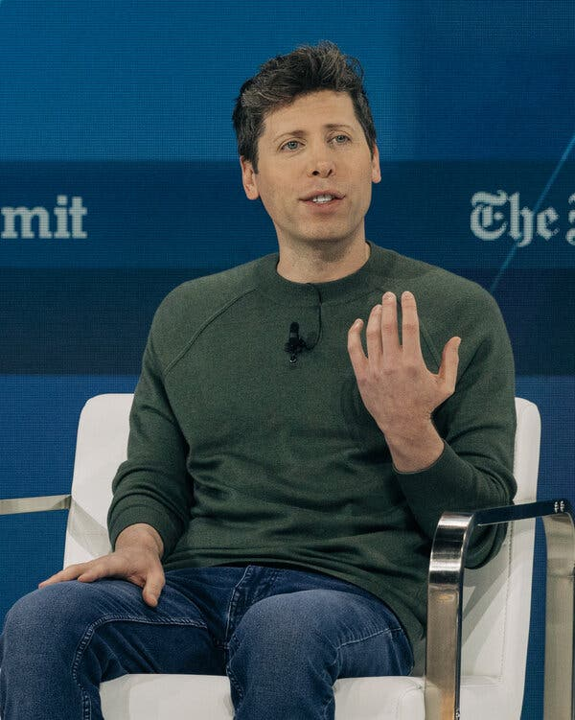

Sam Altman, the chief executive of OpenAI. Mr. Siemiatkowski said on a podcast that he had told Mr. Altman that Klarna would be “their favorite guinea pig.”Credit...Jeenah Moon for The New York Times

Whatever progress Klarna made on automation, Mr. Siemiatkowski sometimes seemed as invested in spinning out a story about A.I. as actually using the technology. In 2024, he and the company regularly put out news releases and conducted interviews, leading to [headlines](https://www.wsj.com/articles/klarna-marketing-chief-says-ai-is-helping-it-become-brutally-efficient-4ad388d3) like “Klarna Marketing Chief Says A.I. Is Helping It Become ‘Brutally Efficient,’” in The Wall Street Journal.

By the time Mr. Siemiatkowski made the rounds of prominent tech podcasts that summer, in a tour that included the [popular show](https://www.wsj.com/business/media/acquired-podcast-tech-business-history-strategy-90e73603) “[Acquired](https://www.acquired.fm/episodes/building-a-disruptive-payments-company-with-klarna-ceo-sebastian-siemiatkowski)” and podcasts hosted by [Sequoia](https://www.youtube.com/watch?v=m3niSE-8ZvE) and the venture capitalist [Logan Bartlett](https://www.youtube.com/watch?v=V81MT9B5irU&t=2s), he seemed to have distilled Klarna’s A.I. story to its sharpest narrative elements.

“My understanding is that you told Sam and OpenAI that you wanted to be their guinea pig,” [an interviewer](https://www.youtube.com/watch?v=V81MT9B5irU&t=2s) said.

“Their *favorite* guinea pig,” Mr. Siemiatkowski corrected.

A former Klarna manager, who left in 2022, said the rhetorical emphasis on A.I. was no accident. According to the manager, there was a sense within the company that Klarna had lost its sheen in the media and among investors, and that Mr. Siemiatkowski was desperate to get it back.

Image

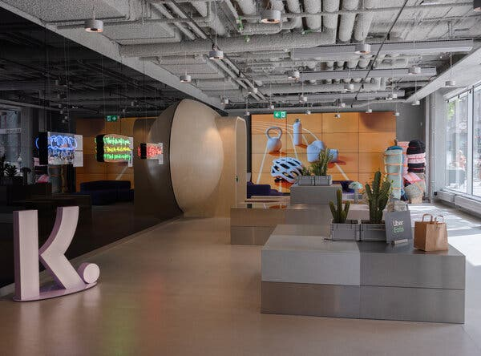

Klarna’s likely public offering is one of the more anticipated of this year, and although some of that reflects the company’s improved financial performance, Mr. Siemiatkowski’s relentless focus on A.I. appears to have been important.Credit...Loulou d'Aki for The New York Times

The former manager said the A.I. story provided a lifeline at a time when Klarna was hoping to offer shares on the public markets. It demonstrated that the company was still on the cutting edge, and that it was shrinking not because it had faltered but because it had figured out how to replace humans with machines.

The effort appears to have worked. Klarna’s likely public offering is [one of the more anticipated](https://www.morningstar.com/stocks/6-ipos-watch-2025) of this year and could fetch triple the valuation that followed its 2022 swoon. Though some of that progress reflects Klarna’s [improved financial performance](https://assets.ctfassets.net/4pxjo1vaz7xk/6ipcoknKXgF3g0QRYO4OxN/f2687797051694f4b486bd55c84cff6e/January_-_September_2024_Klarna_Holding_AB__publ_.pdf) over the past year and a half and the upward march of the market overall, Mr. Siemiatkowski’s relentless focus on A.I. appears to have been important. “The benefits of A.I. are likely to be a key selling point for any Klarna I.P.O.,” The Financial Times [wrote](https://www.ft.com/content/bfd9af3d-d607-4877-9571-078ab82a837e) last year.

It does not appear to have hurt that Mr. Siemiatkowski is willing to go much further in his A.I. pronouncements than fellow C.E.O.s, telling the paper, “Not only can we do more with less, but we can do much more with less.”

Mr. Siemiatkowski’s statements are sometimes sweeping or grandiose because, former employees say, he sees himself as a righteous warrior in a fight with powerful forces. “I have always been anti-establishment,” he said at one all-hands meeting. “To me, what we’ve been doing here, going after the banks, is to be anti-establishment.”

As with his challenge to Swedish banks and his standoff with the union, Mr. Siemiatkowski’s A.I. campaign appears to be another instance of self-interest merging with heroic self-conception.

When the host of the “Big Technology Podcast” [asked why](https://www.youtube.com/watch?v=34P1XLXmEUI) he was so intent on talking up Klarna’s A.I. prowess, Mr. Siemiatkowski said it was partly for the good of humanity.

“We have a moral responsibility to share that we are actually seeing real results and that that’s actually having implications on society today,” he said. “To encourage people, specifically politicians in society, to actually treating this as a serious change that’s coming.”

Then he acknowledged that another part of the motivation was “self-promotion, for sure.” He added, “We’re regarded as a thought leader.”

**Saying What Investors Can’t**

Mr. Siemiatkowski may have at times overstated what A.I. has accomplished at Klarna, but that doesn’t mean he’s wrong about the future.

Image

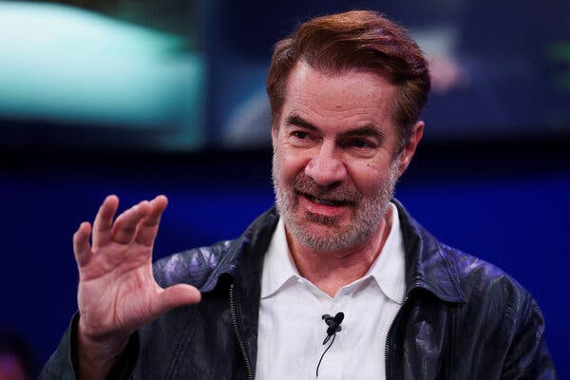

Erik Brynjolfsson, a Stanford economist, said that he thought “people exaggerate how much they can automate everything in the near term,” though he acknowledged that more tasks could be automated as A.I. became more powerful in the future.Credit...Yves Herman/Reuters

Dr. Brynjolfsson of Stanford notes that most office jobs are collections of tasks, and that while A.I. can take on some of them, it still struggles to combine most or all of them in the manner of a human.

But even he believes that could change within a few years, while a growing number of tech experts argue that artificial general intelligence — a bot that can do anything the human brain does — is not far-off. Mr. Altman of OpenAI [recently predicted](https://blog.samaltman.com/reflections) that A.I. agents — bots than can perform relatively complicated tasks on their own— would soon “join the work force” and “materially change the output of companies.” Others [have predicted](https://www.nytimes.com/2023/10/16/technology/ai-agents-workers-replace.html) that such agents will take over a wide variety of jobs.

Many tech investors are already banking on this outcome, effectively counting on automation to save their huge bets on free-spending A.I companies. In an [influential analysis](https://www.sequoiacap.com/article/ais-600b-question/) last year, the venture capitalist David Cahn estimated that the combined A.I.-related revenue of companies like OpenAI and Microsoft was likely to be hundreds of billions a year less than the amount needed to pay back investors.

But one way to make the numbers add up is if employers can save hundreds of billions of dollars using A.I. to replace workers in the relatively near future. In that case, the revenue of companies like OpenAI could grow rapidly and their investors could earn a profit. (They might still risk [being undercut by Chinese competitors](https://www.nytimes.com/2025/01/27/technology/what-is-deepseek-china-ai.html) who can build similar technology at lower cost, though that would also make it cheaper for employers to automate work.)

The catch is that very few investors and top executives are willing to discuss this in plain language. When it comes to the question of job loss, those with a large financial interest in A.I. tend to euphemize and equivocate.

Even Mr. Altman, one of the foremost proponents of the idea that A.I. will soon be capable of advanced humanlike cognition, has increasingly avoided discussing the potential downside for workers. Two years ago, [he conceded](https://www.youtube.com/watch?v=hn1Y6GVWUV0) that A.I. would take over certain jobs and that the shift in power from labor to capital “goes way further in a world with A.I.” By last year, he had toned down this language, [telling a podcaster](https://lexfridman.com/sam-altman-2-transcript) that he, too, imagined A.I. taking over tasks rather than whole jobs and that it would allow people to do work at “a higher level of abstraction.” He did this even as — or perhaps because — he seemed to think the technology was becoming vastly more powerful.

(OpenAI declined to comment. The New York Times has [sued](https://www.nytimes.com/2023/12/27/business/media/new-york-times-open-ai-microsoft-lawsuit.html) OpenAI and its partner, Microsoft, for copyright infringement. The two tech companies have denied the claims.)

Mr. Siemiatkowski has brought clarity to this discussion. In his eagerness to court investors, and in his tendency to overstate the case and say the quiet part out loud, he has laid bare Silicon Valley’s ambition. In his own slightly muddled way, for his own slightly idiosyncratic reasons, he is helping to surface a conversation that has largely been whispered in the executive suites.

Investors in his presence sometimes become so excited about the possibilities of displacing humans that they forget to deploy the usual euphemisms and aphorisms. During a [podcast interview](https://www.youtube.com/watch?v=HkNBqn-nGlMc) with Mr. Siemiatkowski, a partner at the prominent venture firm Kleiner Perkins gushed about Klarna’s “full-on automation at scale” and said, “That’s where it’s eyebrow-raising.”

At times, even Mr. Siemiatkowski can be wrong-footed by such directness. When another podcaster [asked](https://www.youtube.com/watch?v=m3niSE-8ZvE) which jobs were most likely to be automated, he seemed momentarily flustered, then reached for a joke he’d told Sam Altman.

“I said to Sam, ‘What you should focus on, try to build A.I. that replaces C.E.O.s, bankers and lawyers,’” he recalled, identifying three unpopular jobs. “‘Nobody will make a big fuss about it.’”